EVALUATING INNOVATION INJECTION INTO EDUCATIONAL CONTEXTS
Abstract: One of the big challenges faced by research in the Technology Enhanced Learning (TEL) field has to do with the injection of innovation into real educational contexts. Very often, innovative technologies fail to be taken up by practitioners because of difficulties in absorbing both methodological and technological innovation of the target contexts. This may be caused by resistance of the target users associated with conservatism of the contexts, but also by inadequate approaches to innovation promotion or even lack of evidence of the return of investment of the innovation itself. Thus, a crucial need of the TEL field consists in the ability to evaluate both the efficacy of a new technology in the specific context to permeate, and the effectiveness and adequacy of the intervention designed to inject this innovation into the intended situation. This paper contributes to fill in this gap by proposing an approach that joins aspects of Guskey’s model to evaluate the effectiveness of teacher training events together with indicators of the well-known Technology Acceptance Model, generally used to predict acceptance of a new technology. The approach proposed, called T&EAM (Technology&Event Acceptance Model), is illustrated. The discussion concerns its strengths and weaknesses and provides inputs for future applications and research.
Keywords: Technology Enhanced Learning (TEL); evaluation; technology acceptance; training programme evaluation; innovation; Technology Acceptance Model (TAM).

Introduction
In many projects in the Technology Enhanced Learning research field, a frequent objective is to develop and inject methodological and technological innovation into a ‘virgin’ educational context. This process of exogenous (i.e. externally-driven) educational innovation usually leverages on teachers and is typically triggered by training events aiming to familiarize them with the technology, and then entails some kind of follow up, where they are scaffolded and guided through their first steps in the use of the new technology in real life contexts. In these situations, policy makers and/or researchers need to evaluate the results of such actions, both in terms of technology acceptance, and training event adequacy and effectiveness.
In this paper, we propose a ‘joint approach’, called T&EAM (Technology&Event Acceptance Model), built upon the conjunction of two existing and consolidated models, which have been merged to form a single framework for the evaluation of a technology-based educational innovation and the associated teacher training events.
Our ambition is to set the basis for the development of a framework that can be adopted in many other TEL projects, provided that they share the need of evaluating the effects of an innovation being injected into a new context.

Theoretical background
Bearing in mind that the issue we intend to address here is the definition of an approach to evaluate the combined effects of the introduction of a new technology in a given context (and its methodological underpinnings) and of a training event addressing the perspective users, our literature review focuses on both aspects of the problem: the evaluation of the impact of a new technology in a given context and the evaluation of training events/programmes, and specifically those that aim to improve a teaching and learning process.
Both of these areas are very rich: there is plenty of models and framework addressing these issues, some of which are very well-known and consolidated. With no ambition to be exhaustive, in the following sections we concentrate first on some of the most popular models to evaluate the impact of technological innovation, and then we focus on the evaluation of training programmes.

Models for technology impact evaluation
A number of models have been proposed in the last decades to analyse and predict user acceptance of new technological tools (Davis, 1989; Rogers, 2010; Thompson, Higgins, & Howell, 1991; Venkatesh & Davis, 2000; Venkatesh, Thong, & Xu, 2012).
Among these, some of the most well-known aim to predict users’ intentions towards technology, and actual usage of it, as dependent variables, on the basis of various determinants (i.e. independent variables) that include: attitudes, perception of usefulness, perception of ease of use, motivation (both extrinsic and intrinsic), and other social factors. One of the most popular, the Technology Acceptance Model (TAM) (Chuttur, 2009; Davis, 1989), focuses on two determinants, Perceived Usefulness and Perceived Ease of Use, and has given rise to several derivatives and evolutions, often used in educational contexts (Cheung & Vogel, 2013; Liu, Chen, Sun, Wible, & Kuo, 2010; Persico et al., 2014; Tarhini, Hone, & Liu, 2013). For example, TAM2 (Venkatesh & Davis, 2000), considers some additional determinants concerning social influence, including for example Subjective Norm, defined as “the person’s perception that most people who are important to him think he should or should not perform the behavior in question”(Fishbein & Ajzen, 1975, p. 302). As described in the following, TAM and TAM2 provide the foundations for the development of our evaluation approach, although the three variables (Perceived Usefulness, Perceived Ease of Use and Subjective Norm) are not used as determinants, to predict behaviour, but rather as indicators of acceptance, after usage of the technology.
Besides those cited so far, the following models have been considered in METIS for possible inspiration. The Motivational Model (Davis et al., 1992) focuses on Extrinsic Motivation and Intrinsic Motivation as determinants. This model has been drawn and adapted from the Motivational Theory of the psychological field to fit the information systems domain and model new technology adoption and use (Vallerand, 1997). The Model of PC Utilization (MPCU) by Thompson and colleagues (Thompson et al., 1991) aims to predict PC utilization, and complements the perspectives put forward by TAM; MPCU establishes a framework to study innovation in a wide range of application contexts by considering a wide range of determinants, including Job-fit, Complexity, Long-term Consequences and Social Factors. Roger’s renowned Innovation Diffusion Theory (Rogers, 2010). MPCU, in particular, has been widely applied to the ICT field, and focuses on a number of deteminants, including Relative Advantage, [perceived] Ease of Use, Image, Visibility, and Voluntariness of Use. The Unified Theory of Acceptance and Use of Technology (UTAUT) model (Venkatesh et al., 2003, 2012) is aimed at synthesizing previous TAM versions in an effort to relate technology use to Performance Expectancy, Effort Expectancy and Social Inﬂuence. Interestingly, other aspects that are usually considered important in technology adoption, such as attitude toward using technology, self-efficacy, and anxiety, according to UTAUT do not have a direct impact on technology usage; while other conditions seem to influence technology adoption, including users’ age, sex, experience, and the voluntariness of use.

Models for training initiatives evaluation
As mentioned above, there is a multiplicity of models and studies dedicated to the evaluation of training programmes and training initiatives of different kind. With no intention to be exhaustive, we examine here those that have inspired our approach.
The Kirkpatrick’s 4 levels model is probably one of the most well-known and widely applied. It considers 4 levels of training evaluation: reaction (a measure of satisfaction of the people involved in the training initiative), learning (a measure of knowledge and skills increase), behaviour (a measure of change in behaviour) and results (a measure of the effects on the institutions) (Kirkpatrick, 1994).
Hamblin’s 5 levels model is an extension of Kirkpatrick’s, and it envisages: reactions, learning, job behaviour, organization, ultimate value (i.e.: the financial effects, both on the organization and the economy) (Hamblin, 1974).
Guskey’s 5 levels is also an extension of Kirkpatrick’s model, with the peculiarity of having been adapted to a teacher training context, thus paying special attention to effects on school contexts and students. It encompasses the following levels: participant reaction, participant learning, organizational support and learning, participant use of new knowledge and skills, student learning outcomes (Guskey, 2000).
Other models that have been explored, and have to some extent influenced our work, include:
- Tyler’s model of curriculum development (Tyler, 1942), which for the first time conceives evaluation as a process aimed at gathering comprehensive evidence of learning, rather than just relying on paper and pencil tests;
- the utilization-focused evaluation (Patton, 2000), where evaluation mainly addresses utility and actual use, and evaluators should facilitate the evaluation process and design any evaluation with careful consideration of how everything that is done, from beginning to end, will affect use;
- the Context, Input, Process, and Product (CIPP) evaluation model (Stufflebeam & Shinkfield, 2007), a comprehensive framework for guiding evaluations of programs, projects, personnel, products, institutions, and systems, whose core components are Context, Input, Process, and Product evaluation;
- the (Input-Process Output) IPO model (Bushnell, 1990), aimed at enabling decision makers to select the package that will ensure the effectiveness of a training program;
- the Training Valuation System (TVS) model (Fitz-enz, 1994), that includes situation analysis (similar to an in-depth training analysis), intervention (diagnosing the problem and designing the training), impact (the variables that impact on performance), and value (monetary worth on the changed performance).

The T&EAM approach
This section describes the T&EAM approach, the associated indicators, as well as the tools to be used for data collection.

Evaluating the technology with the T&EAM approach
As already mentioned, the TAM and its subsequent evolutions were chosen as the backbone approach to evaluate the technology in ten T&AM approach, even if it is acknowledged that this model was originally devised as a predictive tool. However, Persico et al. (2014) have already shown how the TAM indicators “perceived ease of use” and “perceived usefulness” can be used for ex-post assessment of the impact of a technology, by collecting information concerning users’ opinions about these two indicators and complementing them with data gathered from other sources, such as observation and data tracked by the system itself. Furthermore, the subjective norm indicator introduced by TAM2 are also to be used.
The reasons for the choice of TAM and TAM2 indicators (Venkatesh & Davis, 2000) as main indicators of the T&EAM approach, are two-fold: first, the number of experiences and studies where they had been applied, witness their capacity to adapt to several different contexts, even when it comes to assessing teachers’ acceptance of technology (Huntington & Worrell, 2013; Persico et al., 2014). Especially in those studies concerning the barriers to technology uptake by teachers (Delfino, Manca, Persico, & Sarti, 2004; Lambert, Gong, & Cuper, 2008; Lloyd & Albion, 2009), the TAM indicators have proved to be key determinants and that training initiatives can improve some of these factors, to increase the chances that the proposed technology is adopted in the long run.
A second reason for this choice is that these models are applicable to any technology, provided that their indicators and the evaluation means are tailored to the system structure, functions and user types. This process of adaptation/tailoring is essential, especially when dealing with formative evaluation, in such a way to achieve an accurate diagnosis of the problems.
Thus, in our approach the “perceived ease of use” and “perceived usefulness” indicators are used to build data collection tools aiming to understand the users’ opinions after use of the technology during ad hoc training event(s). In our model, these subjective data are then complemented with more objective data about actual usage of the system. This latter information is typically obtained thanks to tracking mechanisms built in the technology, usually with learning analytics techniques (Authors, 2014). These data provide, among other things, a measure of trustworthiness of the users’ opinions. If, for example, a user says that a given functionality was easy to use, but tracked data show he/she never used it, his/her opinion is less trustworthy than that of a user who claims the functionality was difficult to use after having engaged with it for a certain amount of time.

Evaluating the workshops with the T&EAM approach
According to the proposed approach, the evaluation of the training initiative(s) used to introduce the technology in one context, can be carried out according to Guskey’s model (2002). In this model, derived from Kirkpatrick’s work (1994), evidence is collected and analysed at five critical levels: 1) workshop participants' reactions (i.e. perceptions on the training event) 2) workshop participants' learning (i.e. knowledge and skills gained); 3) organization support and change (i.e. impact on the organization where the participants work and organisation’s support to the implementation of the innovation); 4) participants' use of new knowledge and skills (i.e. application of the acquired competence in the teaching profession); 5) student learning outcomes (i.e. impact on the students who are the ultimate beneficiaries of the innovation proposed).
While most evaluation models focus on levels 1 and 2, Guskey’s model also takes into consideration factors that can facilitate or hinder innovation within an organization (level 3) and long term effects of the training events on participants (level 4), as well as on their students (level 5), and this is the main added value of this model in respect to the others.
According to the T&EAM, while level 1 to 3 are typically gauged at the end of the training event(s), level 4 and 5 data collection take place after the follow up (medium term). The data collected from training participants are also complemented with data concerning the actual training sessions. These data are collected during the events typically by an observer, taking notes on the basis of a rubric.

Data collection process
Overall, in the T&EAM approach we have merged the TAM and the Guskey’s models, have customized their original indicators, so to form a unique evaluation framework, in such a way that data collection and data analysis are conducted by means of joint evaluation means.
The resulting T&EAM approach (see Fig. 1) allows to strike a balance between the need to carry out a deep analysis and evaluation of different aspects of the technology and the training events, on one hand, and the requirement to keep the effort of the users relatively low, so to make the approach more sustainable.
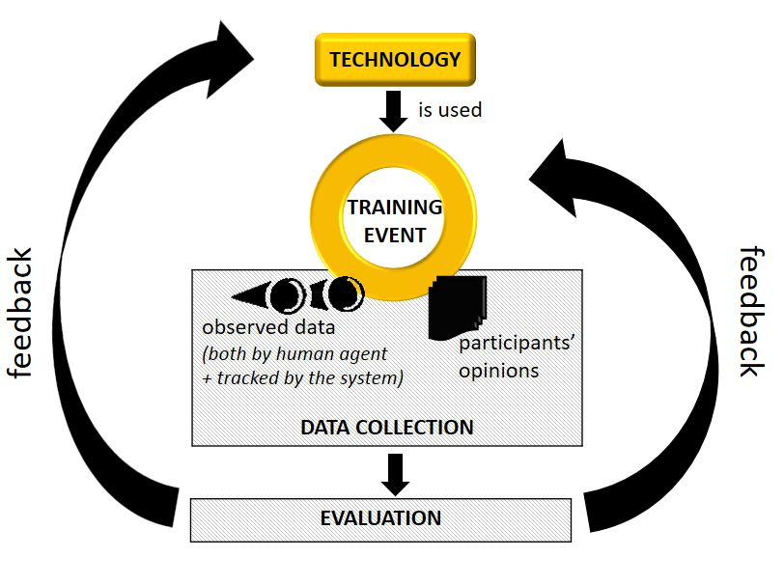
Fig. 1 The T&EAM evaluation approach

Fig. 1 represents the cyclic process of data collection and evaluation providing feedback on both the technology and the teacher training events. The data collected concern:
• Participants’ opinions, gathered at the end of the training event(s), in a very easy and relatively unobtrusive way through questionnaires and interviews;
• Actual participants’ behavior during the events, annotated by human observers and/or automatic tracking.
The complete list of indicators is reported in Table S1 of the Supplementary file 1.

Managing evaluation within projects
Sometimes, when one boosts an innovation into a real context, this is done in the context of complex (European) projects, where several parallel events are held and data need to be collected in a homogenous and comprehensive way (Authors, 2015). The actors usually involved in projects of this kind, comprise a number of institutions/agents that carry out the pilot of the training events in one or more contexts (indicated as the trainers, in the following), plus one institution usually leading the evaluation (identified as the evaluator in the following), and one actor in charge of the development and tuning of the technology (the developer) (see Fig. 2).
The coordinating institution (the coordinator) could be any of the above, although it is preferable that the evaluator is in charge of evaluation only, to avoid conflicts of interest. The evaluator usually devises or instantiates the evaluation model, designs and produces the evaluation tools, coordinates data collection (which is carried out on site by the trainers) and carries out the data analysis (see Fig. 2).
In case the evaluation involves institutions in different countries, language problems need to be handled with the support of local partners; so, for example, the questionnaires should be developed in one common language (typically English), and translated into the local languages. A first phase of analysis of any narrative (answers to open questions or interviews) should be carried out by the trainers, based on common guidelines provided by the evaluators, to produce raw data in English that can easily be interpreted by the evaluators.
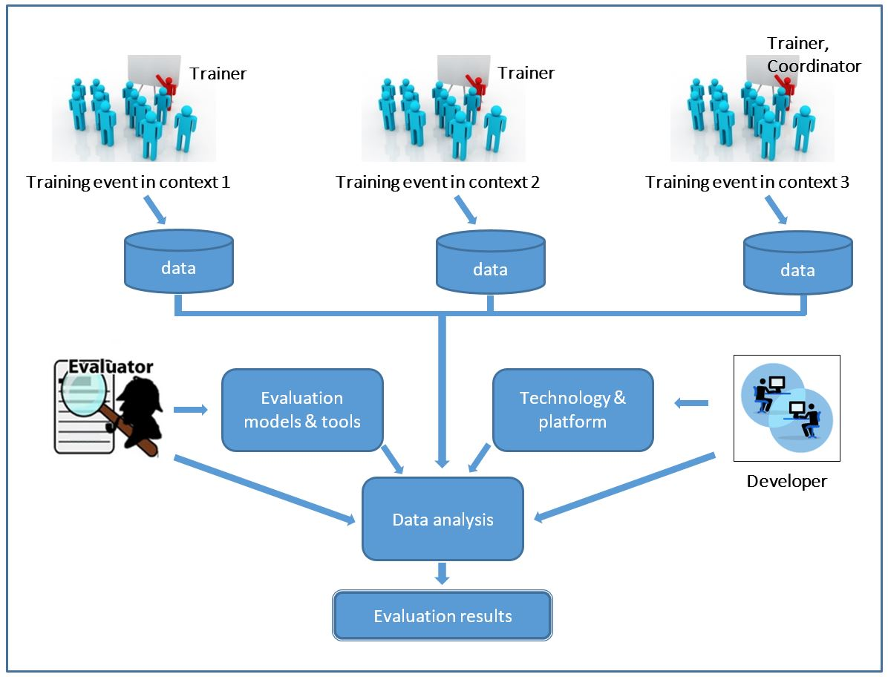
Fig. 2 Collaborative evaluation of training events according to the T&EAM approach

Discussion
The T&EAM approach has been developed and experimented for the first time in METIS, a LLP Project aiming to foster methodological and technological innovations in learning design. In this project, the authors of this paper where in charge of the evaluation workpackage (Authors, 2013; Authors, 2015a; 2015b). Within METIS, the target of the innovation were three different educational contexts (namely Higher Education, Vocational Training and Adult Education), thus the evaluation approach was applied to these three situations. Indeed, the T&EAM approach proved flexible enough to fit in with the three different contexts, and appears to be potentially exportable to several other educational contexts (Authors, 2015).
Furthermore, within the METIS project the application of the T&EAM evaluation approach yielded important results, providing useful feedback and suggestions for improving and tuning both the proposed technology and the training format, so to increase the possibility that the technology is then taken up by other actors in the same (or similar) contexts.
The approach allowed us to collect the data in a very unobtrusive way, with data collection carried out by the project partners in charge of the training in each context according to the guidelines provided by the evaluators.
The questionnaires and the interview rubrics were produced in English and translated in Spanish and Greek by the local partners. A first round of the qualitative analysis was carried out locally, to produce English narratives corresponding to the open answers to questionnaires and interview transcripts.
This organization allowed for the T&EAM approach to be easily and consistently adopted and managed even by the partners who were not directly involved in its conceptualization. In particular, the online questionnaire proved to be very easy to be managed, once translated in the local languages; the interviews, carried out by the local partners based on a common rubric provided in English, were slightly more complicated, because they required a certain amount of time and an effort to produce a synthesis in English of the interviewee answers. Data collection through interviews was possible as long as the number of interviewees is relatively small; in case of big numbers, probably they should be replaced by questionnaires or even group data collection techniques, such as focus groups.
As far as the indicators are concerned, the ones deriving from the TAM model and devoted to evaluating technology acceptance proved very effective. Given that in METIS the technology was rich of functions to be evaluated, in order to make it easier for respondents to recall the functions the questionnaire was investigating, questions were enriched with pictures of the platform, so to highlight the interface controls associated to the various program functions. This proved to be an effective strategy that allowed the users to straightforwardly understand the questions.
The indicators focusing on the training coming from Guskey’s model were also very useful: not only did they yield information about the adequacy of the workshops in the different contexts, but they also informed us about the possibility that the technology is really taken up in the various situations. Some problems emerged when collecting data for I6 (Student outcomes), as it turned out to be particularly challenging for teachers to collect these data on the field and almost impossible to compare them with students’ outputs obtained before the technology was introduced. In particular, as it often happens in TEL research, evidence about students learning appears very difficult to assess, as innovative methods and technologies cannot be easily compared with traditional ones. Probably, structured data collection protocols would have helped teachers to systematically collect significant data about students learning ad this is something that should be fixed for future adoption.
Another challenge posed by the T&EAM approach regarded the juxtaposition of the data tracked by the system and those coming from the questionnaires and interviews. One of the reasons for these difficulties is the difference of granularity between the data typically tracked by the platform and those collected through the questionnaires and interviews. While the former are usually low level data, concerning individual actions of the users, the latter are higher-level data referring to the technology functions. Their comparison might require some effort to elaborate and aggregate the tracked data, so that they can be used to put in the right light the users’ opinions on the technology functions.
As a last consideration, we should note that, usually the life span of a project is rather short and does not allow to wait for long term evidence that the innovation really permeates the target system. However, what can realistically be evaluated is the acceptance of the technology, the impact of the training event, as well as the short/medium term changes compared to the original conditions of the target context(s).

Conclusions
The T&EAM evaluation approach presented above aims to assess the acceptance of an innovative technology, when this is introduced for the first time into an educational context through some kind of training programme.
The novelty of the model lies not so much in the indicators and tools used, which mainly derive from other existing and well-known evaluation models, but rather in the way they are used and integrated into one coherent evaluation framework thus producing an overarching model. The proposed evaluation means jointly assess the technology and the training events and consider all the variables that may affect the uptake of the innovation, in order to produce a picture of the forces that may foster or hinder the integration of the innovation into real conditions.
Even if the T&EAM has been conceived in the framework of one specific project, we believe the problem addressed is frequent in the TEL field, where many of the projects funded by the EC or other funding agencies aim to introduce methodological and technological innovation into established educational systems; for this reason, further research directions should aim to investigate transferability to projects with similar intents.
As to the authors, further research efforts will be devoted to the identification of the invariant factors of the model and of the degrees of freedom left to the evaluators when applying the model.

Acknowledgement
This study was funded by Project METIS (Meeting teachers co-design needs by means of Integrated Learning Environments) – EC Lifelong Learning Programme (Project Number: 531262-LLP-1-2012-1-ES-KA3-KA3MP. Agreement n° 2012-3971/001-001).
The authors declare that they have no conflict of interest.
Data can be made available upon request to the corresponding author.

References
Bushnell, D. S. (1990). Input, Process, Output: A Model for Evaluating Training. Training and Development Journal, 44(3), 41–43.
Cheung, R., & Vogel, D. (2013). Predicting user acceptance of collaborative technologies: An extension of the technology acceptance model for e-learning. Computers & Education, 63, 160–175. doi:10.1016/j.compedu.2012.12.003
Chuttur, M. (2009). Overview of the Technology Acceptance Model: Origins, Developments and Future Directions. Sprouts: Working Papers on Information Systems, 9(37).
Davis, F. D. (1989). Perceived Usefulness, Perceived Ease of Use, and User Acceptance of Information Technology. MIS Quarterly, 13(3), 319–339. doi:10.2307/249008
Davis, F. D., Bagozzi, R. P., & Warshaw, P. R. (1992). Extrinsic and intrinsic motivation to use computers in the workplace. Journal of Applied Social Psychology, 22(14), 1111–1132.
Delfino, M., Manca, S., Persico, D., & Sarti, L. (2004). Online learning: attitudes, expectations and prejudices of adult novices. In V. Uskov (Ed.), Proceedings of the IASTED Web-Based Education Conference (pp. 31–36). Calgary, Canada: ACTA Press. Retrieved from http://ben.upc.es/butlleti/innsbruck/416-121.pdf
Fishbein, M., & Ajzen, I. (1975). Belief, attitude, intention and behavior: an introduction to theory and research. Reading, Ma: Addison-Wesley Pub.Co.
Fitz-enz, J. (1994). Yes...You Can Weigh Training’s Value. Training, 31(7), 54–58.
Guskey, T. R. (2000). Evaluating Professional Development. Thousand Oaks: Corwin Press.
Guskey, T. R. (2002). Professional Development and Teacher Change. Teachers and Teaching, 8(3/4), 381–391. doi:10.1080/135406002100000512
Hamblin, A. C. (1974). Evaluation and Control of Training. Industrial Training International, 9(5), 154–156.
Huntington, H., & Worrell, T. (2013). Information Communication Technologies in the Classroom: Expanding TAM to Examine Instructor Acceptance and Use. Journal of Educational Multimedia and Hypermedia, 22, 147–164.
Kirkpatrick, D. L. (1994). Evaluating training programs: The four levels. San Francisco, CA: Berrett-Koehler.
Lambert, J., Gong, Y., & Cuper, P. (2008). Technology, Transfer and Teaching: The Impact of a Single Technology Course on Preservice Teachers’ Computer Attitudes and Ability. Journal of Technology and Teacher Education, 16(4), 385–410.
Liu, I.-F., Chen, M. C., Sun, Y. S., Wible, D., & Kuo, C.-H. (2010). Extending the TAM model to explore the factors that affect Intention to Use an Online Learning Community. Computers & Education, 54(2), 600–610. doi:10.1016/j.compedu.2009.09.009
Lloyd, M., & Albion, P. (2009). Altered Geometry: A New Angle on Teacher Technophobia. Journal of Technology and Teacher Education, 17(1), 65–84.
Patton, M. Q. (2000). Utilisation-focused evaluation. In Evaluation models (pp. 425–438). Boston, Ma: Kluwer Academic Publishers.
Persico, D., Manca, S., & Pozzi, F. (2014). Adapting the technology acceptance model to evaluate the innovative potential of e-learning systems. Computers in Human Behavior, 30, 614–622. doi:10.1016/j.chb.2013.07.045
Authors (2015a).
Authors (2015b).
Authors (2013).
Authors (2015).
Authors (2014).
Rogers, E. M. (2010). Diffusion of Innovations (4rt ed.). New York, NY: Simon and Schuster.
Stufflebeam, D. L., & Shinkfield, A. J. (2007). Evaluation theory, models, and applications (Vol.3). San Francisco, CA: Jossey-Bass.
Tarhini, A., Hone, K., & Liu, X. (2013). User Acceptance Towards Web-based Learning Systems: Investigating the Role of Social, Organizational and Individual Factors in European Higher Education. Procedia Computer Science, 17, 189–197. doi:10.1016/j.procs.2013.05.026
Thompson, R. L., Higgins, C. A., & Howell, J. M. (1991). Personal Computing: Toward a Conceptual Model of Utilization. MIS Quarterly, 15(1), 124–143. doi:10.2307/249443
Tyler, R. W. (1942). General Statement on Evaluation. The Journal of Educational Research, 35(7), 492–501. doi:10.1080/00220671.1942.10881106
Vallerand, R. J. (1997). Toward a hierarchical model of intrinsic and extrinsic motivation. In M. P. Zanna (Ed.), Advances in experimental social psychology, Vol.29 (pp. 271–360). San Diego, CA, US: Academic Press. doi: 10.1016/S0065-2601(08)60019-2
Venkatesh, V., & Davis, F. D. (2000). A Theoretical Extension of the Technology Acceptance Model: Four Longitudinal Field Studies. Management Science, 46(2), 186–204. doi:10.1287/mnsc.46.2.186.11926
Venkatesh, V., Thong, J., & Xu, X. (2012). Consumer Acceptance and Use of Information Technology: Extending the Unified Theory of Acceptance and Use of Technology. MIS Quarterly, 36(1), 157–178.

http://www.metis-project.org/

